
North Bengal International University

Lab Report: 04
Exp Name : A program to short an array using Bubble short in c program .

Subject : Data Structure
Subject Code : CSE 0612-2131

Submitted By:
Name : Md. Tanvir Rahman Pranto
Dept : CSE
Roll : 0712340012101005
Semester : 2nd Year, 4th semester.

Submitted To:
Name : Saifur Rahman
Designation : Lecturer
Dept : CSE
Date :

Code:
#include <stdio.h>

int main() {
int a[6] = {5, 2, 9, 1, 6, 3};
int n = 6, i, j, temp;

printf("Before sorting: ");
for (i = 0; i < n; i++) {
printf("%d ", a[i]);
}
printf("\n");

for (i = 0; i < n - 1; i++) {
for (j = 0; j < n - i - 1; j++) {
if (a[j] > a[j + 1]) {
temp = a[j];
a[j] = a[j + 1];
a[j + 1] = temp;
}
}
}

printf("After sorting: ");
for (i = 0; i < n; i++) {
printf("%d ", a[i]);
}
printf("\n");

return 0;
}

Output:
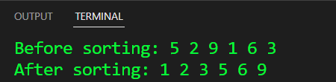

Conclusion: This program sorts an array using Bubble Sort, repeatedly swapping adjacent elements until the array is in order. It’s simple, effective, and great for small datasets

a[j] a[j+1] a[j] > a[j+1] Swap
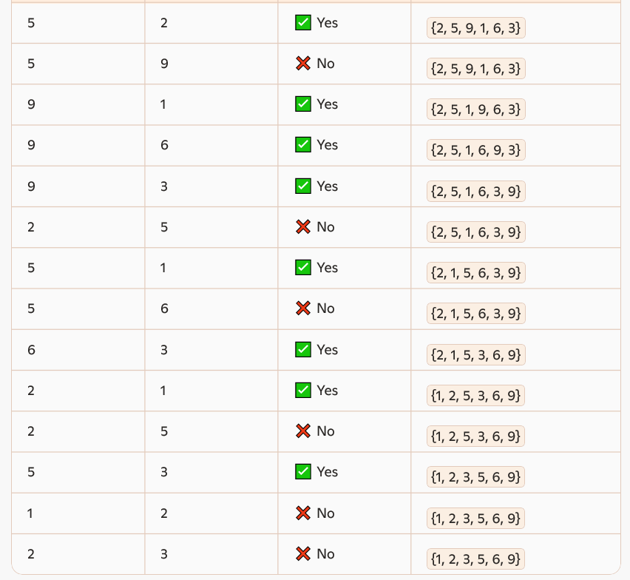

Final sorted array: **1 2 3 5 6 9**

